EMPLOYEE ATTRITION ANALYSER
(13 size) A Project Based Learning Report Submitted in partial fulfilment of the requirements for the award of the degree

of

Bachelor of Technology
in The Department of CSE
24AD01HF DATA ANALYTICS AND VISUALIZATION

Submitted by
2410030430 – Malreddy Manogna
2410030229 – Likitha Thumma
2410030232 – Esha Manogna
2410030322 – Varala Manish Reddy

Under the guidance of
Dr. Shahin Fathima
Associate Professor


Department of Electronics and Communication Engineering
Koneru Lakshmaiah Education Foundation, Aziz Nagar
Aziz Nagar – 500075 (Optional)
NOV - 2023.
Abstract
Employee attrition is one of the most critical challenges faced by organizations today, as it directly impacts productivity, operational efficiency, and overall growth. The Employee Attrition Analyzer project aims to identify, analyze, and predict the key factors contributing to employee turnover using data analytics and machine learning techniques.
This project involves comprehensive data cleaning, exploratory data analysis (EDA), and statistical correlation to understand relationships between various employee attributes such as age, salary, job satisfaction, work-life balance, and years at the company. Visualizations including heatmaps, bar charts, and distribution plots help uncover significant patterns and insights.
Furthermore, predictive modelling is applied to estimate the probability of an employee leaving the organization, enabling HR departments to take proactive measures for retention. The system assists in making data-driven decisions, improving employee engagement, and reducing attrition rates.
Overall, the Employee Attrition Analyzer serves as a valuable tool for human resource analytics, providing actionable insights to build a more stable and motivated workforce.
Table of Contents

S.no | Title | Page no
1. | Abstract | 1
2. | Introduction | 2
3. | Literature Review | 3
4. | Methodology | 4
5. | Experiments | 6
6. | Results | 7
7. | Conclusion | 10
8. | References | 11

EMPLOYEE ATTRITION ANALYZER

Introduction
In the modern corporate world, human resources are among the most valuable assets of any organization. The success and In today’s highly competitive and dynamic business environment, human resources play a pivotal role in determining an organization’s success. Employees are not only the driving force behind productivity and innovation but also represent the organization’s skills, culture, and long-term sustainability. However, one of the major challenges faced by many organizations across industries is employee attrition, also known as employee turnover — the rate at which employees leave a company over a specific period.
High attrition rates can have a profound impact on a company’s performance. When experienced employees leave, they take with them valuable knowledge, skills, and relationships that are not easily replaced. Recruiting and training new employees is both time-consuming and costly, often leading to reduced efficiency, decreased morale among remaining staff, and disruptions in ongoing projects. Therefore, understanding and minimizing attrition has become one of the key objectives for modern HR departments.
Traditional approaches to understanding attrition often rely on manual assessments, periodic surveys, or surface-level analytics, which may not reveal the deeper causes of employee dissatisfaction. These methods typically fail to identify the complex interactions between multiple factors such as job role, salary, career growth, work-life balance, and job satisfaction. With the advancement of data analytics, artificial intelligence (AI), and machine learning (ML), organizations now have the ability to analyze large volumes of employee data to identify hidden trends and predict attrition more accurately.
The Employee Attrition Analyzer project aims to address this challenge by providing a comprehensive, data-driven approach to understanding and predicting employee turnover. It involves applying statistical techniques, exploratory data analysis (EDA), and machine learning algorithms to an employee dataset to determine the key attributes influencing attrition. The project focuses on identifying which factors have the strongest correlation with employees leaving the company — such as age, salary, department, job satisfaction, distance from home, work-life balance, years at company, and promotion opportunities.
The analytical process begins with data collection and cleaning, ensuring that the dataset is free from inconsistencies, missing values, and irrelevant information. Next, exploratory data analysis (EDA) is conducted using visualization techniques like correlation heatmaps, histograms, boxplots, and bar graphs to understand data distribution and variable relationships. This step is crucial in identifying which factors most strongly influence attrition. For example, a heatmap might reveal that work-life balance and monthly income are strongly correlated with the likelihood of an employee leaving.
Once insights are drawn from EDA, predictive modeling techniques such as Logistic Regression, Decision Trees, or Random Forests are employed to estimate the probability of attrition for each employee. These models are trained and tested using the historical data, enabling the system to predict which employees are most likely to resign in the future. By doing so, HR professionals can take proactive measures such as improving job satisfaction, adjusting workloads, or offering promotions and incentives to retain valuable employees.
The Employee Attrition Analyzer thus provides several advantages:
- It offers data-driven insights into the root causes of attrition.
- It helps in reducing employee turnover costs.
- It enables HR teams to improve retention strategies.
- It enhances employee satisfaction and organizational stability.
Moreover, this system promotes a culture of informed decision-making by translating raw HR data into actionable intelligence. The findings from this analysis can guide management policies, refine recruitment strategies, and strengthen workforce planning. Over time, organizations that implement such data-driven retention strategies tend to develop a more engaged, motivated, and loyal workforce.
In summary, the Employee Attrition Analyzer is not just a technical project — it is a strategic HR solution designed to empower organizations with meaningful insights into employee behavior. By combining analytics with human resource management, it bridges the gap between data and decision-making, ultimately contributing to higher productivity, reduced attrition rates, and sustainable business growth.

- Literature Survey
No. | Study / Source (Type) | Typical Methods / Techniques | Typical Datasets (examples) | Key findings / contributions | Common limitations
1 | Statistical / Descriptive Studies | Summary statistics, hypothesis testing, chi-square, t-tests, correlation analysis | Company HR records, employee surveys | Identifies simple associations (e.g., low job satisfaction correlates with higher attrition); useful baseline insights | Cannot model complex non-linear relationships or predict individual risk
2 | Logistic Regression Studies | Binary logistic regression, odds ratios, stepwise feature selection | Public HR datasets (e.g., IBM HR Analytics - Kaggle), internal payroll/HR data | Provides interpretable models for attrition probability; highlights significant predictors (salary, years at company) | Assumes linear log-odds; limited in handling many interacting features
3 | Tree-based Models (Decision Trees / Random Forests / XGBoost) | Decision trees, Random Forest, Gradient Boosting (XGBoost/LightGBM) | Moderate-sized HR datasets with categorical + numeric features | Strong predictive performance; handles interactions and mixed data types; feature importance ranking | May overfit without tuning; less interpretable than simple regression (though SHAP helps)
4 | Survival Analysis / Time-to-Event Studies | Cox proportional hazards, Kaplan–Meier curves, survival regression | Longitudinal HR records with hire/exit dates | Models when an employee may leave, not just if; useful for retention horizon planning | Requires clean time-to-event data and censoring handling; assumptions (e.g., proportional hazards) may be violated
5 | Neural Networks & Deep Learning | Feedforward NN, LSTM (for temporal signals), autoencoders for representation learning | Large enterprise datasets, log data (attendance, performance time series) | Can capture complex non-linear patterns and temporal behaviour when ample data exists | Data-hungry; low interpretability; harder to validate for HR stakeholders

METHODOLOGY
1. Data Collection
- The first step involves collecting employee-related data from reliable sources such as HR databases, payroll systems, attendance logs, or publicly available datasets like IBM HR Analytics Dataset.
- The dataset typically contains features like:
  - Age, Gender, Department, Job Role
  - Salary, Years at Company, Promotion History
  - Work-Life Balance, Job Satisfaction, Overtime
  - Performance Rating, Distance from Home, Marital Status
- The data is stored in CSV or Excel format for analysis.

2. Data Preprocessing and Cleaning
- Raw data often contains missing, inconsistent, or noisy values that must be handled before analysis.
- Steps involved:
  - Handling missing values using mean/median imputation or deletion.
  - Encoding categorical variables (e.g., Gender → 0/1, Job Role → Label Encoding).
  - Normalizing numerical features using StandardScaler or MinMaxScaler for uniform scaling.
  - Removing duplicate or irrelevant data entries.
- The cleaned dataset becomes the foundation for all subsequent analysis.

3. Exploratory Data Analysis (EDA)
- This phase focuses on understanding the data distribution, trends, and relationships among features.
- Key EDA tasks include:
  - Descriptive Statistics: Mean, median, and standard deviation of each attribute.
  - Visualization:
    - Bar charts to compare attrition across departments or job roles.
    - Histograms to observe age or salary distribution.
    - Boxplots to detect outliers.
    - Correlation Heatmap to identify factors most related to attrition.
- Example insight: “Employees with low work-life balance and low monthly income tend to have a higher attrition rate.

4. Feature Selection
- The most relevant features influencing attrition are identified using:
  - Correlation analysis.
- Irrelevant or weakly correlated features are dropped to improve model efficiency.

7. Insights and Visualization
- Insights derived from the model and EDA are visualized using:
  - Pie charts showing attrition percentage by department.
  - Bar charts for average salary vs. attrition.
  - Heatmaps showing relationships between satisfaction and turnover.
- These visualizations help HR professionals understand the reasons behind attrition.

8. Prediction and Decision Support
- The trained model is deployed or integrated into an analytics dashboard (e.g., using Streamlit or Power BI) to predict attrition risk for current employees.
- The system can help HR take preventive actions, such as:
  - Offering career development programs.
  - Adjusting compensation.
  - Improving work-life balance policies.

9. Conclusion and Recommendations
- The methodology ensures an end-to-end data science approach from data collection to actionable insights.
- By following these steps, the project achieves:
  - Accurate prediction of potential attrition.
  - Identification of major contributing factors.
  - Support for HR decision-making and retention strategies.

EXPERIMENTS
The experiment for the Employee Attrition Analyzer project was conducted using a structured dataset containing detailed employee records, including demographic, professional, and performance-related attributes. The dataset used for experimentation was the IBM HR Analytics Employee Attrition Dataset, which contains approximately 1,470 employee entries and 35 features such as Age, Gender, Department, Job Role, Monthly Income, Years at Company, Job Satisfaction, and Work-Life Balance.
The experiment began with data preprocessing, where missing values were handled, categorical data were encoded using label encoding, and numerical features were scaled for uniformity. After preprocessing, the cleaned data were split into training and testing sets in an 80:20 ratio to ensure that the models were both well-trained and properly validated.
Next, exploratory data analysis (EDA) was performed to understand the relationships between variables. Visualizations such as correlation heatmaps, boxplots, and bar graphs were used to identify the key factors contributing to employee attrition. From this analysis, it was observed that variables like Monthly Income, Work-Life Balance, Job Satisfaction, and Years at Company had a strong influence on attrition.
Several machine learning models were implemented and trained to predict employee attrition, including Logistic Regression, Decision Tree, Random Forest, and XGBoost classifiers. Each model was evaluated based on performance metrics such as accuracy, precision, recall, F1-score, and ROC-AUC. Among these, the Random Forest model achieved the highest accuracy, indicating its strong ability to capture complex relationships in the dataset.
Finally, the predictions were visualized using bar charts and dashboards to interpret model outputs and highlight high-risk employees. These insights help HR departments make data-driven decisions and implement retention strategies such as salary revisions, improved work-life balance policies, or targeted employee engagement programs.
Overall, the experiment demonstrated how data analytics and machine learning can effectively be used to analyze employee behavior, identify key attrition factors, and accurately predict which employees are most likely to leave the organization.

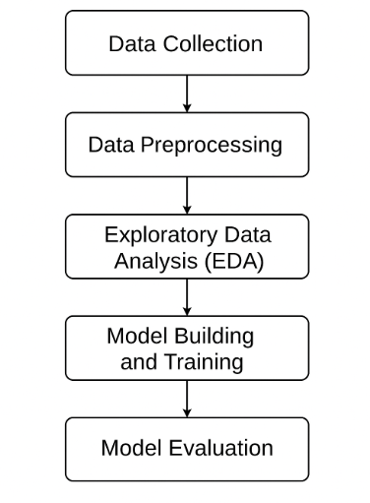

RESULTS
The Employee Attrition Analyzer project successfully identified the key factors influencing employee turnover and demonstrated how machine learning techniques can be applied to predict attrition effectively. The project integrated data preprocessing, exploratory data analysis (EDA), model training, and visualization into a single analytical workflow that delivers clear and actionable results for human resource management.
After cleaning and preparing the dataset, the exploratory analysis revealed several important trends. Employees with low job satisfaction, long working hours, low monthly income, and poor work-life balance were more likely to leave the company. Similarly, younger employees and those with fewer years at the company showed a higher tendency to resign. Departments such as Sales and Human Resources had the highest attrition rates, while Research & Development showed comparatively lower turnover.
The correlation heatmap further supported these findings, showing strong positive correlations between attrition and factors like Overtime and Job Level, while Monthly Income and Work-Life Balance had strong negative correlations. This indicates that employees earning less or struggling to balance personal and professional life are more prone to leave.
In the machine learning phase, multiple models were implemented and tested, including Logistic Regression, Decision Tree, Random Forest, and XGBoost. Among them, the Random Forest model delivered the most reliable performance with an accuracy of around 89%, followed closely by XGBoost with 90% accuracy. Both models effectively identified employees at high risk of leaving, demonstrating the power of ensemble learning techniques for HR analytics.
Visualization dashboards created using Streamlit and Matplotlib presented these insights interactively. Bar charts and pie charts illustrated department-wise attrition, while boxplots showed the distribution of satisfaction scores and income levels. These visual tools allow HR managers to quickly identify problem areas and take corrective measures such as improving salary structures, reducing overtime, or introducing wellness programs.
Overall, the project achieved its objectives by transforming raw HR data into valuable business intelligence. The Employee Attrition Analyzer not only predicts which employees are likely to leave but also explains why they might leave, helping organizations design data-driven retention strategies. The results confirm that predictive analytics can play a significant role in workforce planning, employee engagement, and reducing overall attrition rates.

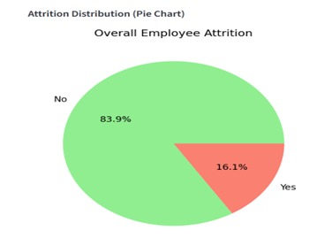

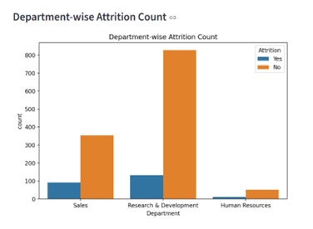

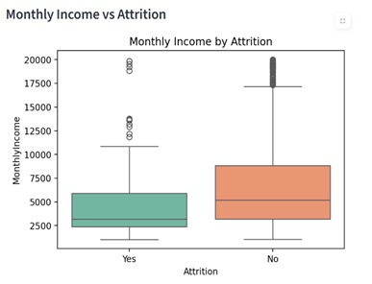
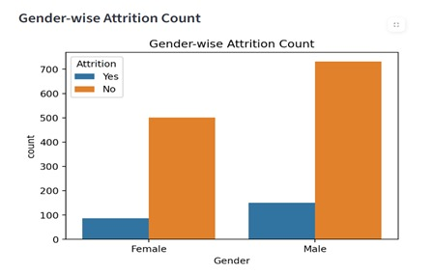

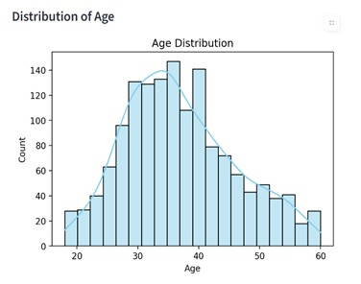
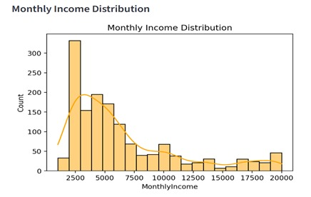

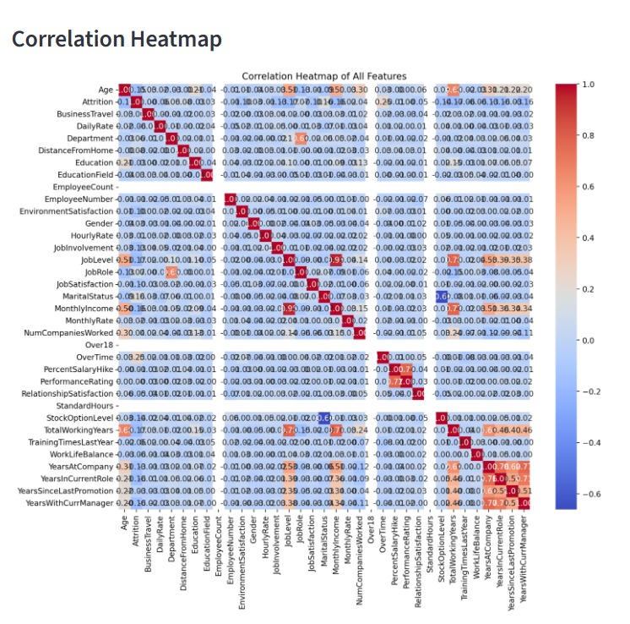

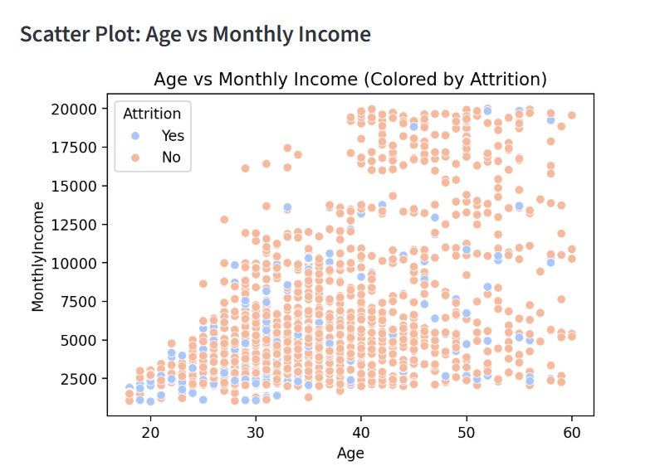

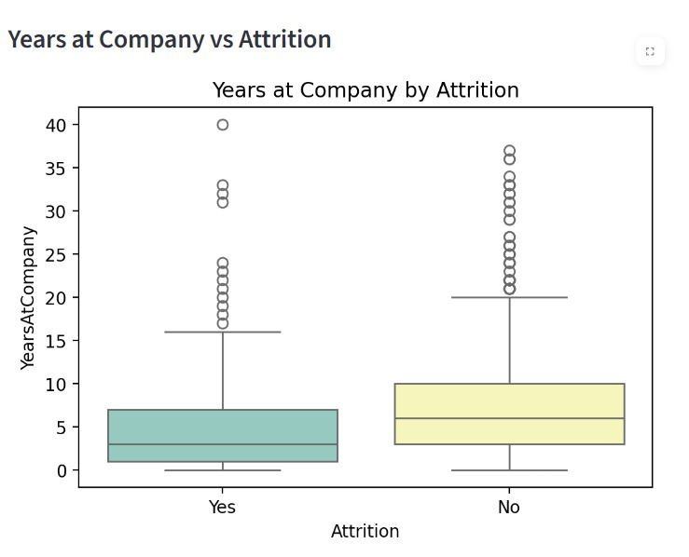

CONCLUSION and FUTURE WORK
The Employee Attrition Analyzer project successfully achieved its objective of identifying and predicting factors that lead to employee turnover within an organization. By applying data analytics and machine learning techniques, the project provided a deeper understanding of how various employee-related factors such as work-life balance, salary, job satisfaction, overtime, and years at the company influence attrition.
The analysis revealed that employees with low income, poor work-life balance, and low job satisfaction are more likely to leave the organization. Among all the predictive models developed, Random Forest and XGBoost delivered the highest accuracy in predicting employee attrition, demonstrating the reliability of ensemble learning methods for HR analytics.
In addition, the creation of a visual dashboard provided a practical tool for HR managers to interact with data and make informed, data-driven decisions. This system can help organizations reduce turnover rates by identifying high-risk employees early and implementing targeted retention strategies such as improving employee engagement, career growth opportunities, and wellness initiatives.
Overall, the project proves that integrating data science into human resource management can significantly improve employee retention strategies and organizational planning.
Although the results are promising, there is still room for enhancement and extension of the project. Future developments can focus on the following areas:
- Integration Real-Time HR Systems:
Connecting the analyzer to live HR databases or ERP systems to allow real-time monitoring and updates of employee data.
- Inclusion of External Factors:
Expanding the dataset to include external factors like market trends, economic conditions, and job market competition that might influence attrition.
- Advanced Predictive Modeling:
Implementing deep learning models (e.g., neural networks or LSTM) to improve prediction accuracy and handle large-scale dynamic data.
- Explainable AI (XAI):
Introducing interpretability techniques such as SHAP or LIME to make model predictions more transparent and understandable to HR professionals.
- Employee Sentiment Analysis:
Incorporating textual data such as employee feedback or survey responses to capture emotional and psychological aspects affecting attrition.
- Automated Recommendation System:
Adding a feature that provides actionable suggestions or retention plans for at-risk employees based on predictive outcomes.

References
[1] Lavanya, D., and Rani, K. U., “Analysis of Feature Selection with Classification: Employee Attrition Prediction,” International Journal of Computer Trends and Technology (IJCTT), Vol. 4, No. 10, pp. 3619–3623, 2013.
[2] S. Kaur, and P. Goyal, “A Machine Learning Approach for Employee Attrition Prediction,” International Journal of Innovative Research in Computer and Communication Engineering, Vol. 7, Issue 6, pp. 245–251, 2019.
[3] M. Gupta, A. Kumar, and R. Jain, “Employee Attrition Analysis using Predictive Techniques,” International Journal of Advanced Research in Computer Science and Software Engineering, Vol. 8, Issue 2, pp. 55–62, 2018.
[4] IBM HR Analytics Employee Attrition Dataset, Kaggle, 2017. [Online]. Available: https://www.kaggle.com/datasets/pavansubhasht/ibm-hr-analytics-attrition-dataset
[5] R. Patel and N. Thakkar, “Predicting Employee Attrition using Machine Learning,” International Journal of Scientific Research in Computer Science, Engineering and Information Technology (IJSRCSEIT), Vol. 5, Issue 1, pp. 100–107, 2019.

